D1_Nihar_84066
ASSSIGNMENT 6
1. D1_nihar_84066>select * from ORDERS where odate in( '1990-10-03', '1990-10-04');
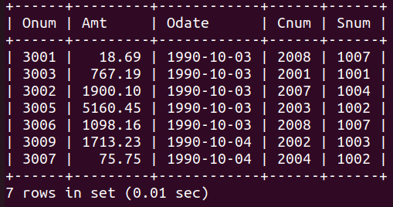

D1_nihar_84066>select * from ORDERS where odate='1990-10-03'or odate= '1990-10-04';
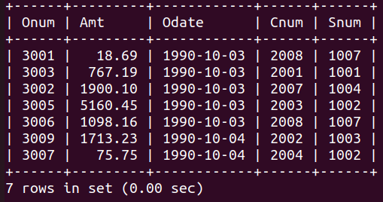

2. D1_nihar_84066>select * from CUSTOMERS where snum in(1001,1004);
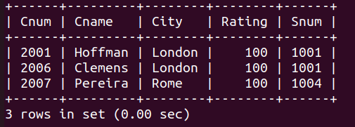

3. D1_nihar_84066>select * from CUSTOMERS where cname>='A%' and cname<'H%';
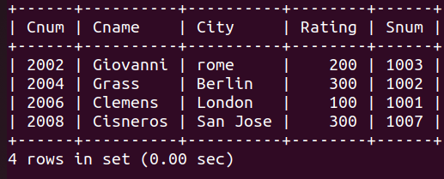

4. D1_nihar_84066>select * from CUSTOMERS where cname like 'C%';
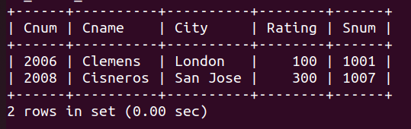

5. D1_nihar_84066>select * from ORDERS where amt!=0 or amt is not null;
